**Exemplar: Calculating profit and margin**

**Overview**

In the exercise *Calculating profit and margin*, you were asked to put into practice what you have learned about the construction and control of calculations.

The tasks that you were asked to complete in the exercise included:

* Creating several single-step formulas.
* Creating two multi-step calculations using brackets.
* Adjusting the formula syntax to allow for copying the calculation using the Autofill feature.

This reading provides you with a step-by-step guide for this process and includes screenshots that you can compare against your own copy. You can also review formula creation techniques in the videos *Controlling calculations* and *Controlling calculations in action*.

**Step 1: Download the file**

You began by downloading the Microsoft Excel workbook *Revenue figures.xlsx.* The worksheet already contained data relating to the stock purchased and associated costs, as well as information on sales. Columns **G**, **H**, **I**, **J**, **L**, and **M** were blank.

**Step 2:  Create the Calculations**

1. You had to create a calculation in cell **G4** to calculate the **Purchase Cost**. The formula in **G4** had to calculate how much the company spent on purchasing the stock items listed in column **F**. Column **E** contained the **Wholesale Cost**, the price the company paid for the stock that they purchased. The formula to calculate the **Purchase Cost** should read: **=E4*F4** The result should read $1,010,216.69.

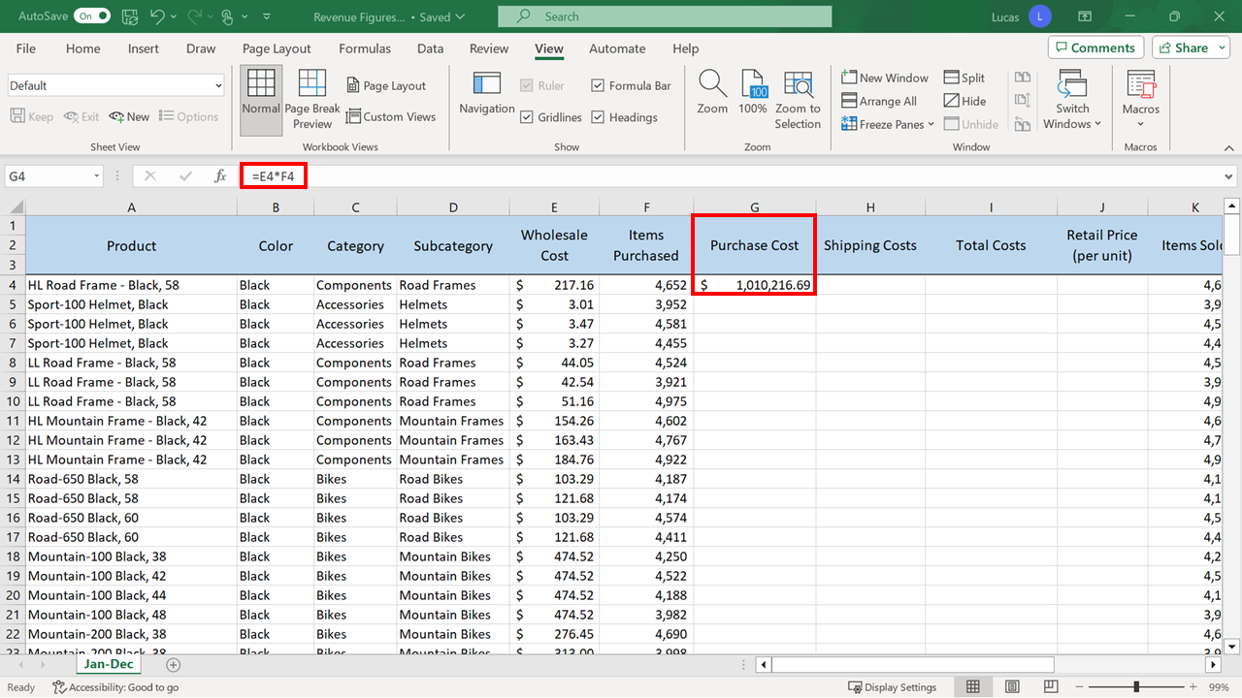

1. You were asked to create a calculation in cell **H4** to work out the **Shipping Costs** for the number of items ordered. The shipping cost was a flat rate of $5 per item and this figure was stored in cell **P1**. To work out the total **Shipping Cost**, the number of items purchased in cell **F4** had to be multiplied by **P1**. The formula had to be copied into the cells underneath as far as row 200. Because the **P1** reference needed to remain constant during the copy process, you added dollar signs to that reference in the formula. The formula in **H4** should read: **=F4*$P$1** The result should be $23,260.

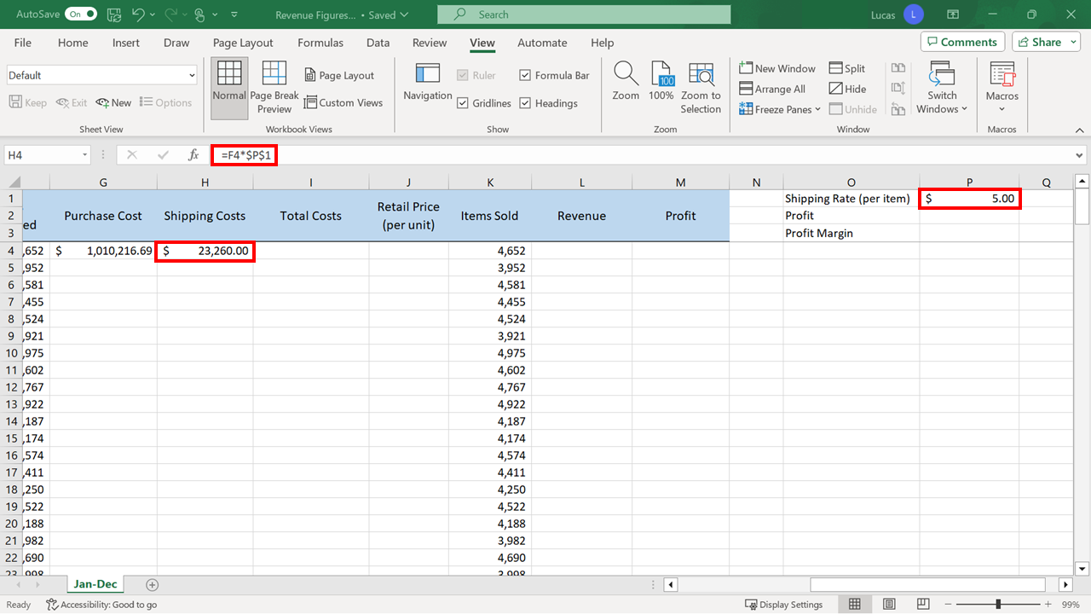

1. You needed to create a calculation in cell **I4** that added together the **Purchase cost** and **Shipping cost**. The addition formula in cell **I4** required to complete this action was: **=G4+H4** The result was $1,033,476.69.

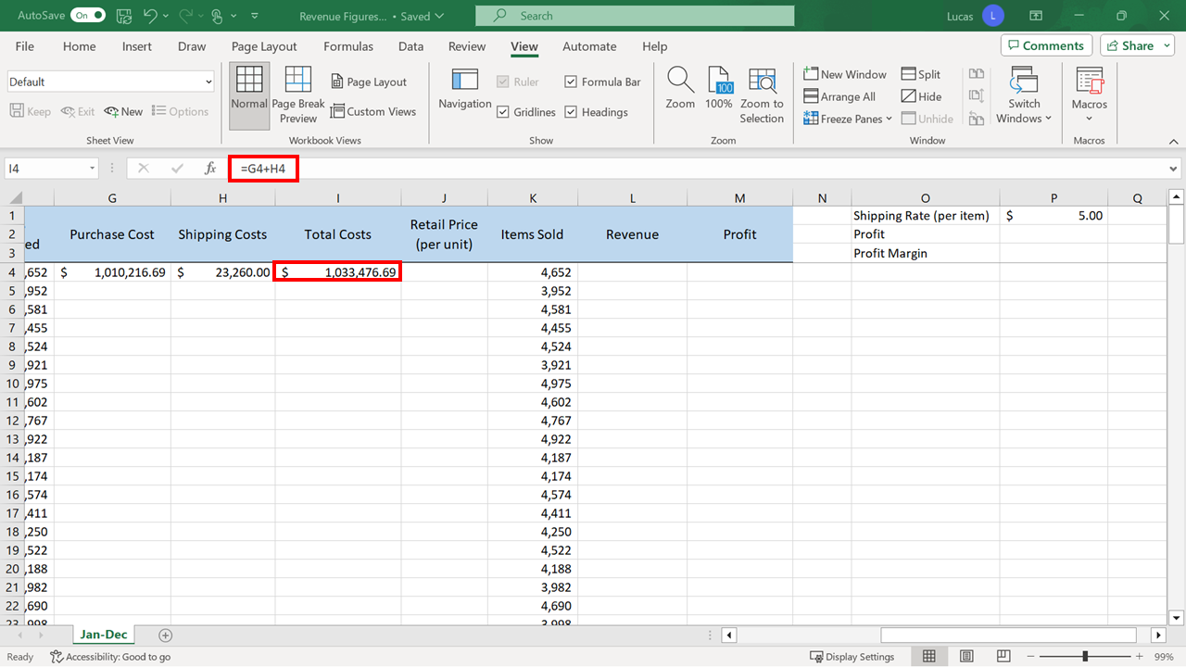

1. You were asked to create a formula in **J4** to work out the **Retail Price** for an individual item. This retail price had to be set high enough to cover the **Wholesale Cost** of each item plus the **Shipping Cost** for the individual item and also a 50% markup. The formula required in **J4** was a two-step calculation. The **Wholesale Cost** and the **Shipping Cost** for a single item had to be first added together. That total had then to be multiplied by a specific percentage to create the new **Retail Price.** It is important that the addition was performed before the multiplication. Excel would naturally try to do the multiplication first, so parentheses were added to control the order in which Excel processed the two steps. This formula was then copied into the cells underneath as far as row **200**. Dollar signs were included in the calculation because the **P1** reference needed to stay constant during the copy process. The calculation in the example uses the following syntax for the calculation: **=(E4+$P$1)*150%** You might also have written it as follows: **=(E4+$P$1)*1.5** This would have achieved the same result. The result should be $333.24.

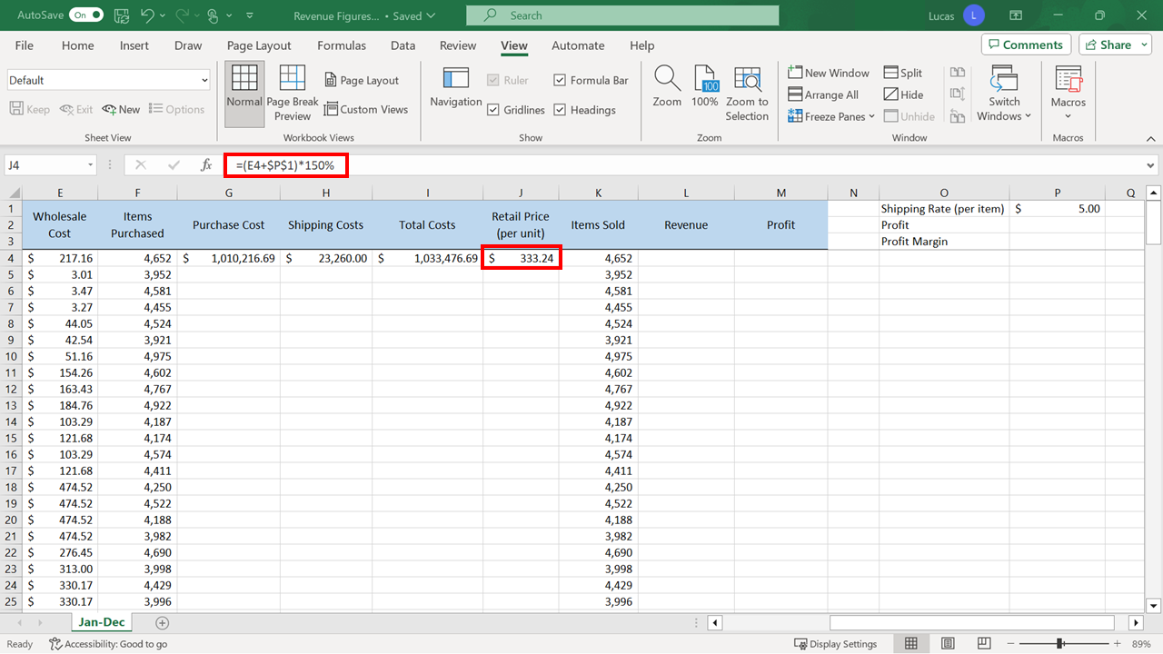

1. You needed to create a calculation in **L4** that worked out the amount of **Revenue** the company earned by selling the number of items listed in **K4** by the **Retail Price** you had just calculated in **J4**. The numbers for Items sold were in column **K**. The formula in **L4** should read as: **=K4*J4** The result should be $1,550,215.04.

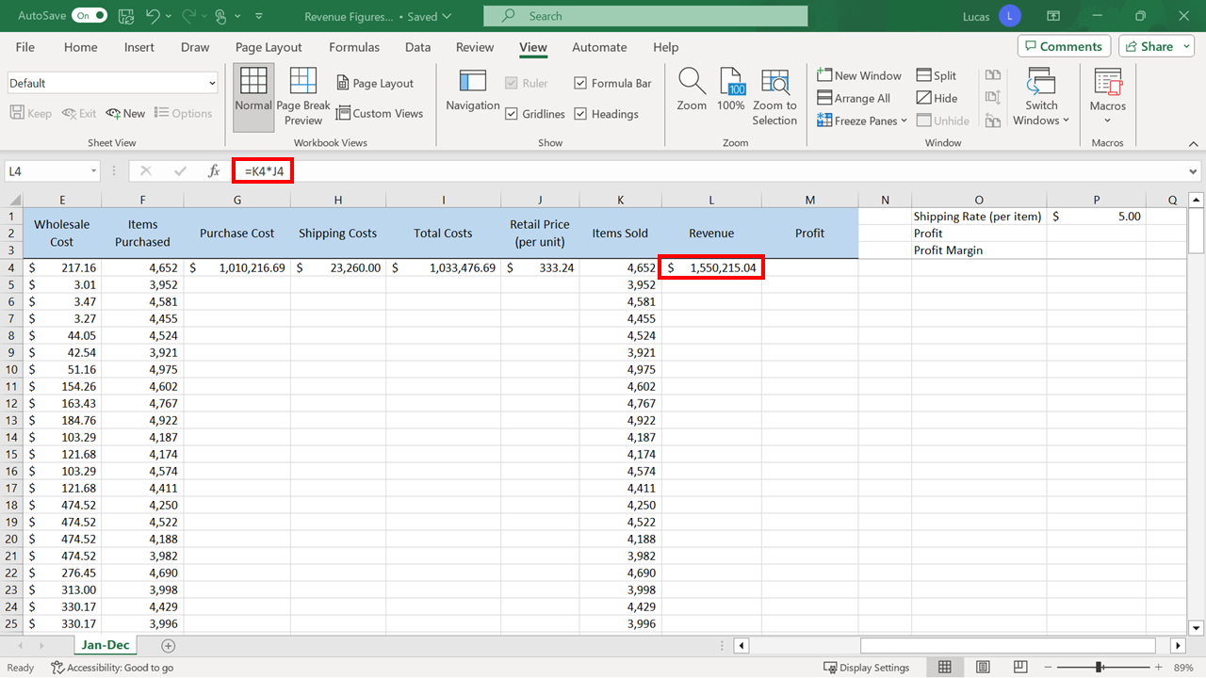

1. In **M4** you needed a formula to subtract the **Total Cost** figure from the **Revenue** figure to generate the **Profit** figure. The **Profit** calculation was a single-step calculation to subtract the **Total Costs** from the **Revenue** to determine the **Profit** made on this first item. The formula should read: **=L4-I4** The result is $516,738.35.

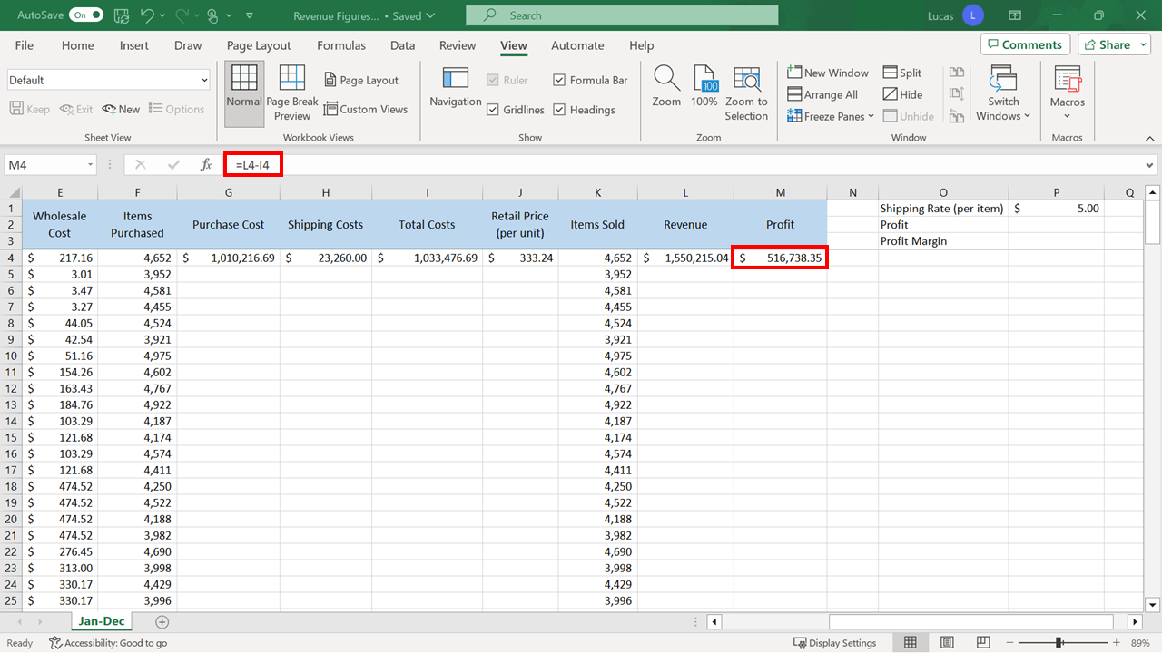

1. Your next was to use the **Autofill** shortcut on cell **G4** to copy the formula down. You then repeated this for the formulas in **H4**, **I4**, **J4**, **L4**,and **M4**. The **Autofill** feature is a quick way to copy the formulas when they are created, into the cells underneath in the column. When you clicked on cell **G4**, there was a block of data immediately to the left in column **F**.Excel can use this as a visual marker so the quickest way to **Autofill** was to position the cursor on the bottom right-hand corner and double-click. **Autofill** would also work if there had been a block of data immediately to the right in column **H**. This shortcut would not have worked on a cell that did not have data on either side. In that situation, you would have had to manually drag down to **Autofill** the entries. The copy-down process was repeated for columns **H**, **I**, **J**, **L**, and **M** if you moved left to right. Overall totals automatically appeared in row **201** in cells **G201** to **M201** because they contained formulas. You should also have noticed the profit figure within cell **P2** at the top of the sheet. When you clicked on this figure, you noticed that it contained the simplest formula of all, which is to make one cell equal to another.

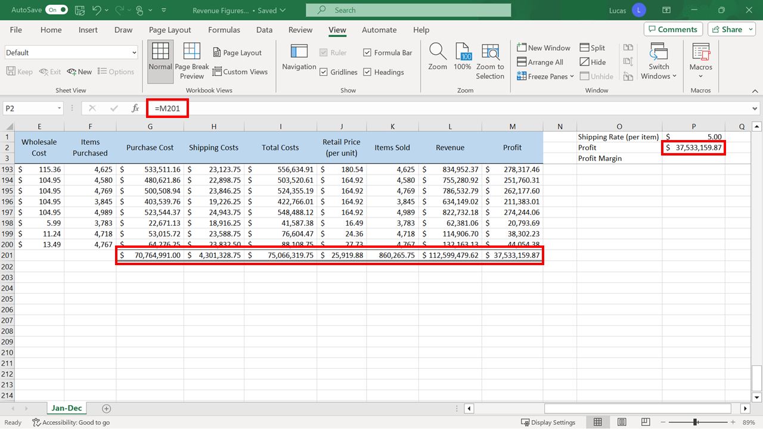

1. Cell **P3** of the worksheet had to display the **Gross Profit Margin**. A profit margin figure indicates what percentage of the sales turned into profit. The logic for this formula is: =(Total Revenue – Total Costs)/Total Revenue In this situation, the **Revenue Total** was in cell **L201** and the **Total Costs** figure was in cell **I201.** The brackets were necessary to ensure that Excel processed the subtraction before the division. In cell **P3,** the formula to work out the profit margin should read as follows: **=(L201-I201)/L201** The result should be 33.33%.

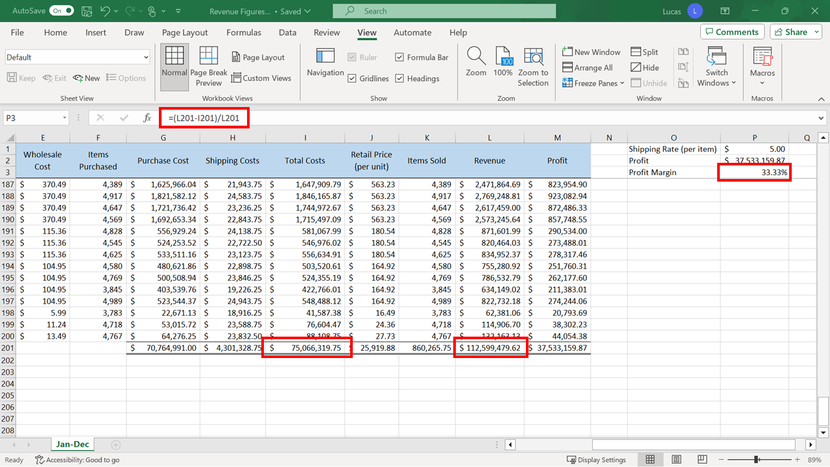

**Conclusion**

Congratulations! You have successfully finished this exercise and added all the required formulas to the worksheet.

Go to next item